BridgePoint Project Analysis Note

Model View Management

# 1. Abstract

This note analyzes a solution to the model view management strategy.

# 2. History

# 3. Document References

[1] ClearQuest DEI dts0100538625 Request for ability to color/shade/highlight model elements

[2] ClearQuest DEI dts0100801382 Hide model elements ("stealth mode")

# 4. Background

The current filtering and coloring ability in BridgePoint is far from ideal.

Presently, coloring is handled by an eclipse preference, and is applied to types of graphical elements (all or nothing). Additionally, these color settings are not applied to the model. Instead they are applied to the workspace in use, and are private.

There is no way, currently, to filter elements in the graphical editors.

# 5. Analysis

## 5.1 Use Cases

### 5.1.1. Class Ownership

#### 5.1.1.1 Right-click > Format > Fill Color > blue for all classes owned by Pat.

#### 5.1.1.2 Right-click > Format > Fill Color > red for all classes owned by Chris.

(Note: On class diagrams where the above classes are imported, the imported classes will default to the color given to the class definition.)

### 5.1.2. Element Completion Status

#### 5.1.2.1 Right-click > Format > Fill Color > green for all model elements that are "done".

### 5.1.3. "Differential Engineering"

#### 5.1.3.1 Select an element that will be affected by a particular new requirement or feature to be added to the system.

#### 5.1.3.2 ctl-click to select additional elements on the diagram that will be affected by the new requirement or feature.

#### 5.1.3.3 Right-click > Format > Fill Color > orange to make this graphically visible.

### 5.1.4. Component Type Differentiation

#### 5.1.4.1 Right-click > Format > Fill Color > blue for all components that are digital.

#### 5.1.4.2 Right-click > Format > Fill Color > yellow for all components that are analog.

#### 5.1.4.3 Right-click > Format > Fill Color > purple for all components that are channels.

### 5.1.5. Element Hiding

#### 5.1.5.1 Select an element that you want to hide and that you wish all references to it (on other diagrams) will be hidden as well.

#### 5.1.5.2 ctl-click to select additional elements on the diagram that you wish to render invisible.

#### 5.1.5.3 Right-click > Layer > Add to hidden layer.

The above use cases show that the coloring capability will be used for widely differing purposes. Thus, it is a requirement that the ability to colorize model elements be of a general nature divorced from any particular semantic.

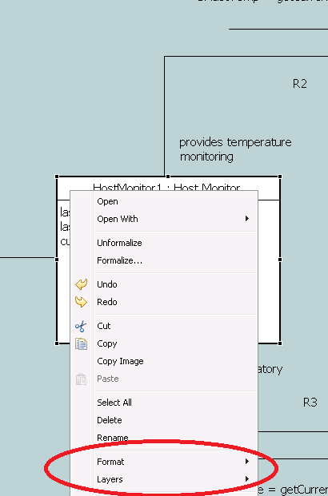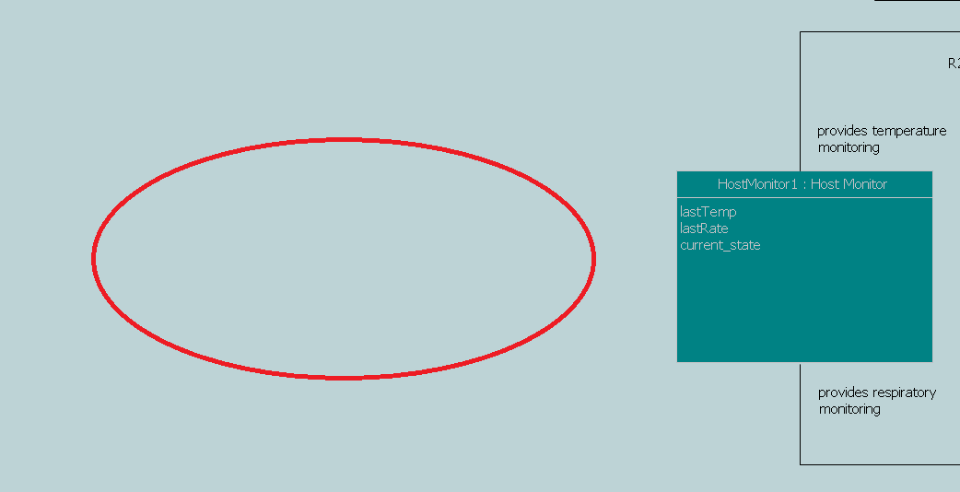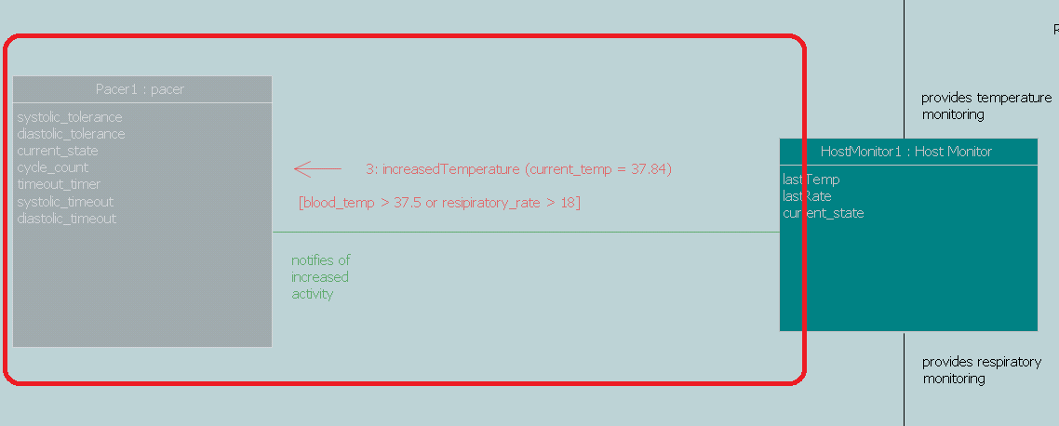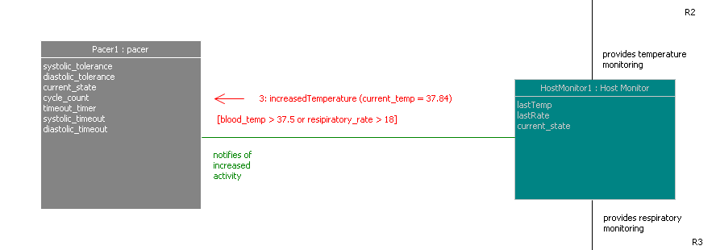

## 5.2 Filtering

The tool needs to support filtering in a way that allows both hiding single elements as well as groups of elements. For groups of elements the tool shall have a management view that allows custom filtering layers. These filtering layers shall allow any graphical element to be added through a context menu. A default filter layer shall always exist, which shall be the hidden layer. When right clicking on a graphical element there shall be a Layers menu, with the following sub menus:

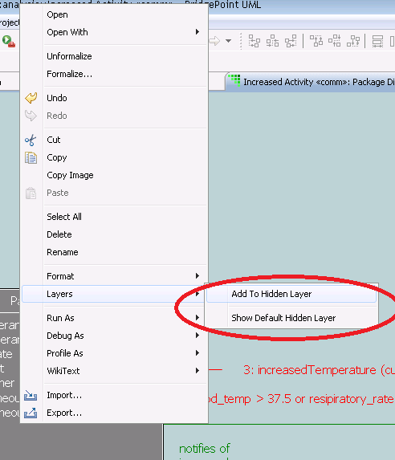Layers > Manage layers...

Add to hidden layer

Add to <custom user label> layer

Remove from layer > Hidden layer

<list of custom user  
 layers that element is participating in>

The **Add to** menu items shall simply register a graphical element in an existing layer. Graphical elements shall be allowed in multiple layers.

The Manage layers... menu item shall open a view or dialog that allows the user to manage the existing layers and add additional layers. The list of layers shall be check box entries, that when checked are shown on the diagram. If an element belongs to more than one layer, it shall show on the diagram if any of its parent layers are selected. If an element belongs to a visible custom layer and belongs to the default hidden layer, then the element shall remain invisible.

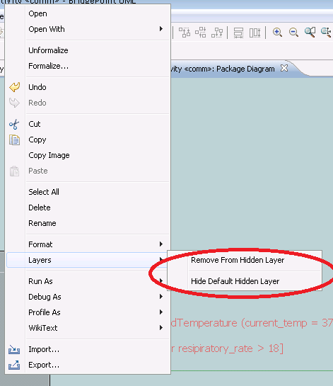

The Remove from layer sub-menu shall allow removal from the default hidden layer if the selection is participating in it. If the selection is not participating in the default hidden layer the menu item should not be present.

Layers shall be configured on a diagram level, and shall be persisted along with the Diagram or Model element. This will allow configured layers to be passed along to all developers of the model.

## 5.3 Coloring

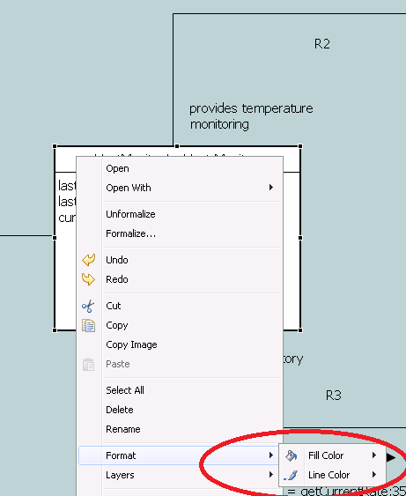Individual graphical elements shall have color support added. When right clicking on a graphical element a new root context menu shall exist named Format. Under this menu there shall be the following sub menus:

Format > Font...

Fill color > <A list of default colors>

Default Color

Custom Color...

Line color > <A list of default colors>

Default Color

Custom Color...

The Font... menu item shall open a font configuration dialog, that allows configuring the font type and font color for the entire symbol. In the future a symbol will be hierarchical, where each piece can have the font configured separately. For example, a Class symbol is currently a box, with the internals drawn as a whole. In the future, the same symbol will have individually selectable compartments and labels. In the future, these shall each have their own font support.

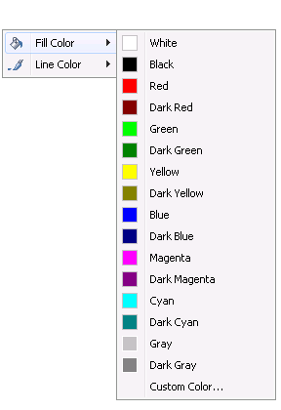

The list of default colors shall be the most common colors used. The Default

Color option shall return the element to the pre-defined color, which in most cases is white for fill and black for line. The Custom Color... option shall open a color chooser and apply the color that is chosen.

Connectors shall have fill color disabled and or hidden from the menu, as the line color is all that applies.

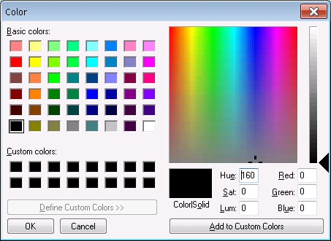

Color settings shall be persisted in the model so that they are shared among all developers. The color settings shall be persisted along with the individual graphical element that was configured.

## 5.4 Inheritance

Referencing elements shall inherit their layer and color properties from the element that they refer to. An example of a referencing element is the Component Reference. In this case the following will occur once the element is configured to refer to its referenced element:

1. It will show if the referenced element is configured to show on its diagram

2. It will not show if the referenced element is hidden on its diagram

3. It will be drawn with the referenced element's font and color settings

Layers that are configured for the referenced element's diagram shall be re-created in the referencing element's diagram. The layer visibility settings shall propagate to the referencing elements' diagrams, but shall not propagate up to the referenced element's diagram.

With the above rules there are some cases where an element, once configured to reference another element, will disappear. In some cases this will prevent necessary configuration before the user configures either the referenced element or the referencing element to be visible on the diagram. An example is with Component Reference, where they cannot be wired until they are configured to reference a Component. If the Component to reference is hidden, the Component Reference will disappear as soon as it is configured to reference the Component. Wiring for such a Component Reference will be impossible until the extra step of showing it on the diagram is taken.

# 6. Work Required

In this section, break out the consequential work (as a numbered list) needed to meet the requirements specified in the Analysis section.

# 7. Acceptance Test

In this section, list the tests that need to be performed in order to verify that all the requirements are satisfied.

End